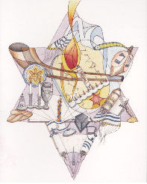
If you would like to make a donation in memory of a loved one, to honor a wonderful person, to celebrate a special occasion or just for the pleasure of doing a mitzvah, please think about giving to our very own CHAVURAT EMET.
It’s A Mitzvah
$36.OO Dedication of a Siddur (Prayer Book)
$18.00 Dedication of a Shivah Minyan Prayer Book
$72.00 Dedication of a Chumash (Bible)
Of course, contributions of any dollar amount can also be made to Chavurat Emet’s general fund.
Name:_____________________________
Enclosed please find my donation for:
$_____ for ____ Prayer Books in Honor/Memory of _______________________.
$_____ for ____Shivah Prayer Books in Honor/Memory of ________________.
$_____ for _____Bibles dedicated in Honor/Memory of ___________________.
$_____ contributed to Chavurat Emet’s general fund in Honor/Memory of _____
_____________________________________________________________.
Please Make your donations payable to Chavurat Emet and mail it with this form to:
Chavurat Emet, P.O. Box 461, Smithtown, NY 11787

